***Simple Project for Home Decoration***

**Index.html**

<!DOCTYPE html>

<html>

<head>

<title>Design Your House</title>

<link rel="stylesheet" href="style.css"/>

</head>

<body>

<div class="banner">

<div class="navbar">

<img src="logo1.png" class="logo">

<ul>

<li><a href="Home_project.html">Home</a></li>

<li><a href="#">Bedroom</a></li>

<li><a href="#">Dining</a></li>

<li><a href="#">Kitchen</a></li>

<li><a href="login_project.html">Login</a></li>

</ul>

</div>

<div class="content">

<h1>Design Your House</h1>

<p>Design your House with us</p>

<div>

<button tye="button">Watch More</button>

<a href="About_us.html"><button tye="button">About us</button></a>

</div>

</div>

</body>

</html>

**Style.css**

*{

margin:0;

padding:0;

font-family:sans-serif;

}

body{

background-image:url(bg5.jpg);

background-size:cover;

background-repeat:no-repeat;

}

.navbar{

width:90%;

margin:auto;

padding:30px;

display:flex;

align-items:center;

justify-content:space-between;

}

.logo{

width:130px;

cursor:pointer;

}

.navbar ul li{

list-style:none;

display:inline-block;

margin:0 10px;

margin-right:40px;

}

.navbar ul li a{

text-decoration:afterline;

color:cyan;

padding:20px;

text-transform:uppercase;

font-weight:bold;

font-size:15pt;

}

.navbar ul li::after{

height:3px;

width:100%;

background:pink;

position:absolute;

bottom:-10px;

}

.content{

width:100%;

position:absolute;

top:50%;

transform:translateY(-50%);

text-align:center;

color:#fff;

font-size:25pt;

line-height:60px;

}

button{

width:200px;

padding:15px;

text-align:center;

margin:20px 10px;

border-radius:25px;

font-size:14pt;

font-weight:bold;

border:3px solid #009688;

background:#009388;

color:white;

cursor:pointer;

}

**Login_project.html**

<!DOCTYPE html>

<html>

<head>

<meta charset="utf-8">

<title>Login Form Design</title>

<link rel="stylesheet" href="login_project.css">

</head>

<body>

<div class="box">

<h2>Login</h2>

<form action="">

<div class="inputBox">

<input type="text" name="" required="First and Last name only" placeholder="Username">

</div>

<div class="inputBox">

<input type="password" name="" required="At least one special character" placeholder="Password">

</div>

<a href="Home_project.html"><button type="button" name="" onclick="">Submit</button></a>

</form>

</div>

</body>

</html>

**Login_project.css**

body {

margin: 0;

padding: 0;

font-family: sans-serif;

background-image: url(bglogin2.jpg);

background-repeat: no-repeat;

background-size: cover;

}

.box {

position: absolute;

top: 50%;

left: 50%;

transform: translate(-50%,-50%);

width: 400px;

padding: 40px;

background: rgba(0,0,0,.4);

box-sizing: border-box;

box-shadow: 0 15px 25px rgba(0,0,0,.5);

border-radius: 10px;

}

.box h2 {

margin: 0 0 30px;

padding: 0;

color: #FFF;

text-align: center;

}

.box .inputBox {

position: relative;

}

.box .inputBox input {

width: 100%;

padding: 10px 0;

font-size: 15px;

color: #FFF;

letter-spacing: 1px;

margin-bottom: 30px;

border: none;

border-bottom: 1px solid #FFF;

outline: none;

background: transparent;

}

.box input{

background: transparent;

border: none;

outline: none;

color: #FFF;

background: #03A9F4;

padding: 10px 20px;

cursor: pointer;

border-radius: 5px;

font-size: 14px;

}

**Home_project.html**

<!DOCTYPE html>

<html>

<head>

<title>Home Page For Interior Design of Home</title>

<style>

body{

background-color:aqua;

}

td{

width:55.5555;

text-align:center;

background-color:orange;

}

img{

height:400px;

width:500px;

margin:30px;

}

div{

text-align:center;

font-weight:bold;

font-size:20pt;

text-decoration:underline;

}

.link1{

text-align:center;

font-size:15pt;

margin:30px;

font-weight:bold;

text-decoration:none;

font-style:italic;

}

</style>

</head>

<body>

<div>

<h2><marquee>Designs of Interior Home Decoration</marquee></h2>

</div>

<table border="1" style="border-collapse:collapse;">

<tr>

<td>

<div>Living Room</div>

<img src="livingroom.jpg" alt="Living Room Design">

<a class="link1" href="https://www.designcafe.com/guides/living-room-interior-styles/#:~:text=Modern%20Style%20Living%20Room&text=A%20natural%20wood%20coffee%20table,making%20space%20warm%20and%20inviting.">More About Living Room Designs</a><br><br><br>

</td>

<td>

<div>Dining Room</div>

<img src="diningroom.jpg" alt="Dining Room Design">

<a class="link1" href="https://interiordesignedu.org/dining-room/">More About Dining Room Designs</a><br><br><br>

</td>

<td>

<div>Bed Room</div>

<img src="bedroom.jpg" alt="Bed Room Design">

<a class="link1" href="https://www.beautifulhomes.com/interior-design-services/design-ideas/bedroom.html#:~:text=A%20bedroom%20designer%20has%20to,vibe%20to%20your%20bedroom%20design.">More About Bed Room Designs</a><br><br><br>

</td>

<td>

<div>Backyard</div>

<img src="backyard.jpg" alt="Backyard Design">

<a class="link1" href="https://www.housebeautiful.com/room-decorating/outdoor-ideas/g1243/amazing-backyard-escapes-0512/">More About Backyard Designs</a><br><br><br>

</td>

<td>

<div>Kitchen Room</div>

<img src="kitchenroom.jpg" alt="Kitchen Desoign">

<a class="link1" href="https://www.nda.ac.uk/blog/kitchen-interior-design-best-use-of-kitchen-space/#:~:text=The%20kitchen%20is%20the%20main,and%20where%20friends%20will%20gather.">More About Kitchen Room Designs</a><br><br><br>

</td>

<td>

<div>Guest Room</div>

<img src="guestroom.jpg" alt="Guest Room Design">

<a class="link1" href="https://www.livspace.com/in/design-ideas/guest-bedroom">More About Guest Room Designs</a><br><br><br>

</td>

</tr>

</table>

</body>

</html>

**About_us.html**

<!DOCTYPE html>

<html>

<head>

<title>About Us</title>

</head>

<body style="background-color:magenta">

<center><br><br><br><br><br><br><br><br>

<h1><u>About Us</u></h1>

<p>This is a full service interior design firm.</p>

<p><b>Contact for more info :</b> interiordecorator@gmail.com</p>

</center>

</body>

</html>

**OUTPUT :**

**Index.html**

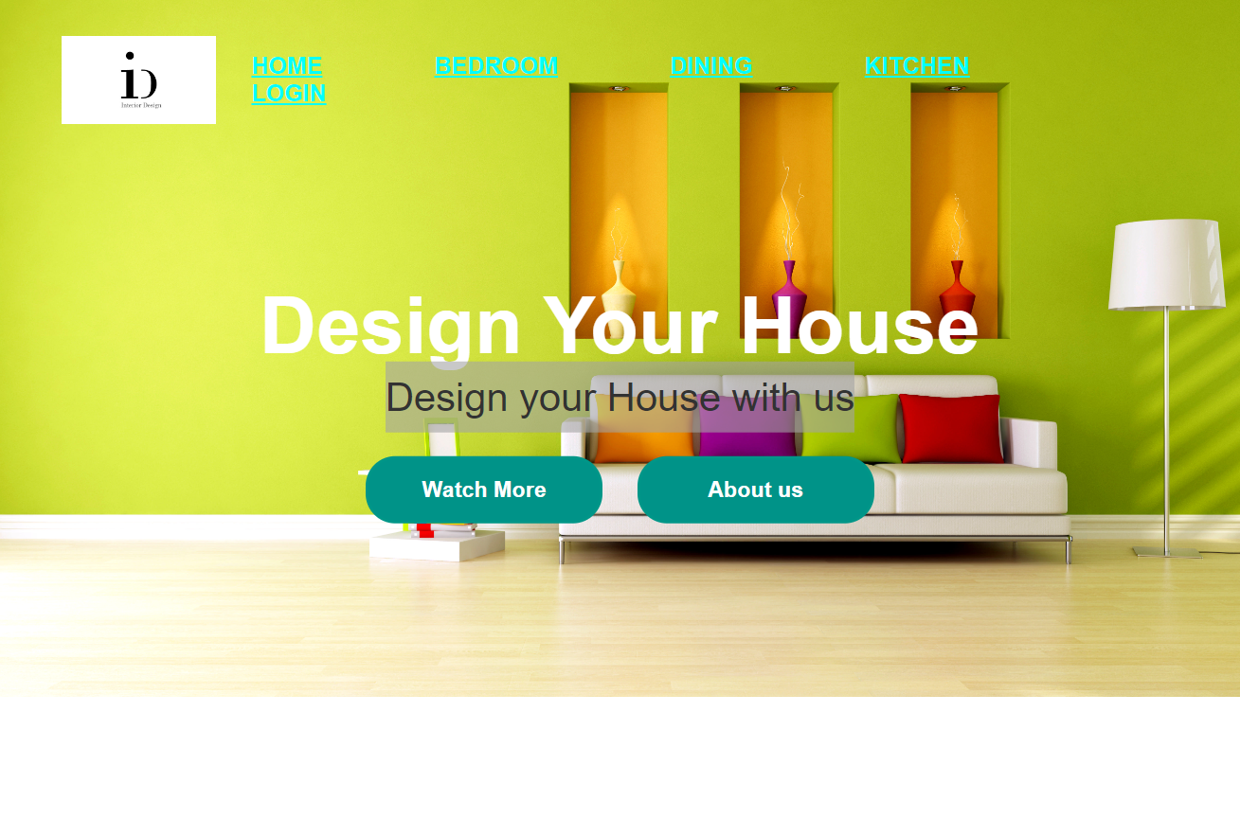

**Login_project.html**

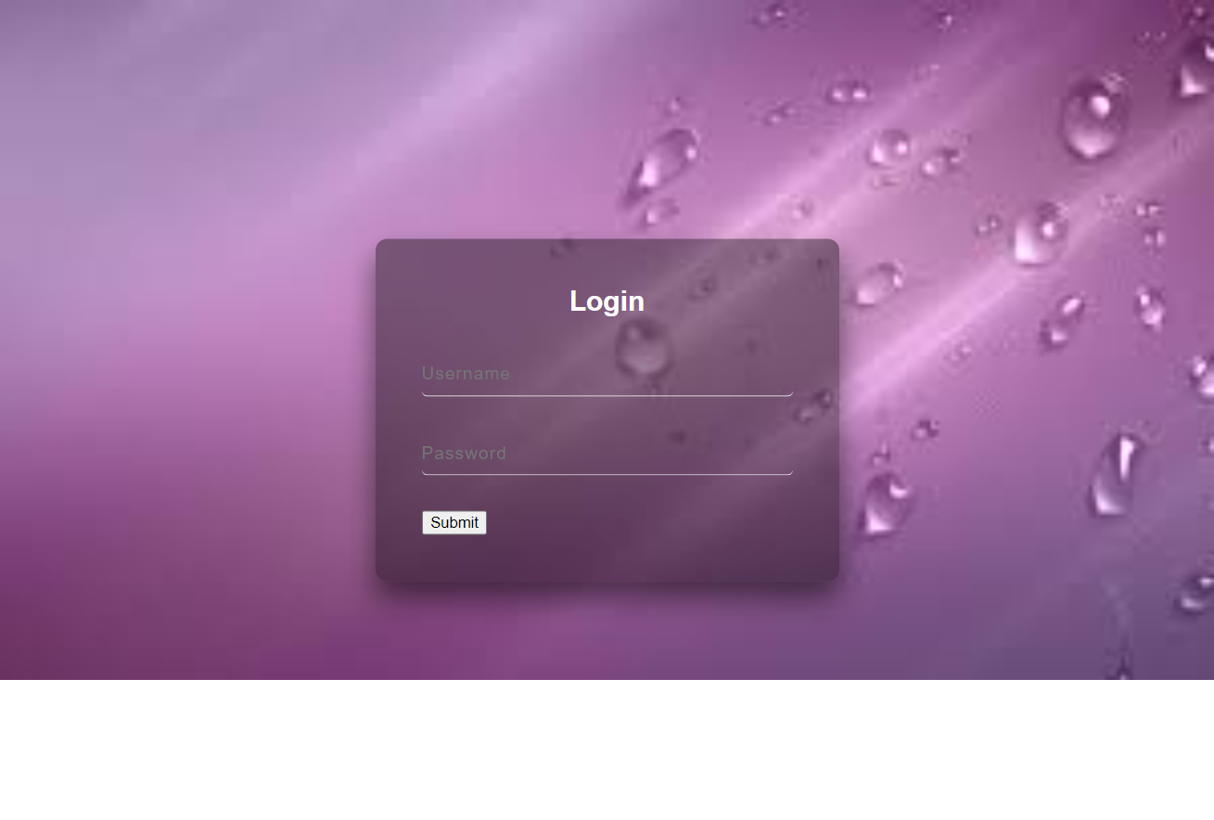

**Home_project.html**

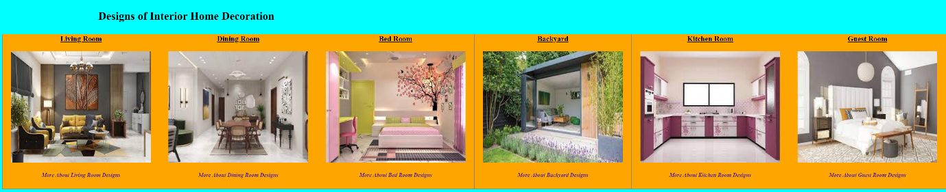

**About_us.html**

